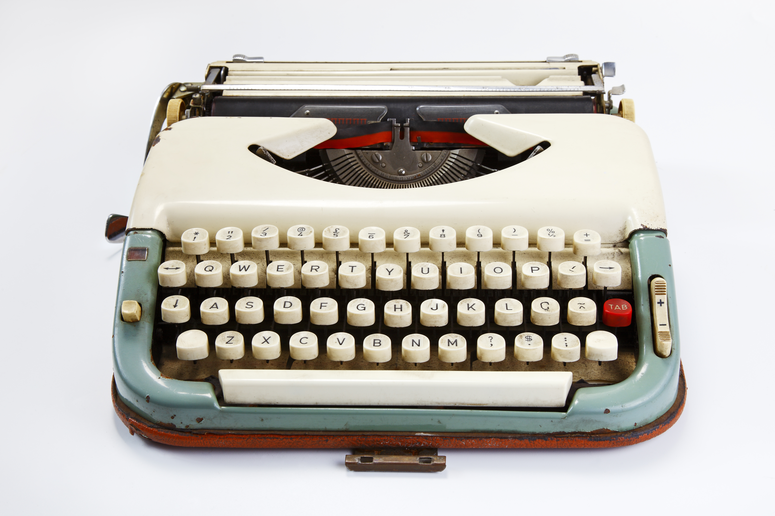

Copywriting Brief

Although this form might look a bit daunting, investing a bit of time in it now will save you lots more time and money by making sure your copy talks to your audience and meets all your needs.

1: Your details
Organisation’s name
Contact name
Email
Phone (and which days of the week you are available)
Date brief is being submitted
Deadline for receiving first draft of copy
Final copy deadline
Organisation details | Please provide a short paragraph outlining who you are, what you do and how you help your clients or service users.
2: Your Project
Briefly describe the overall project that the copy will be a part of.
In what format will the copy appear? | (e.g. a printed four page flyer, an A5 postcard, a web page, an entire website, a downloadable PDF etc)
What do you want the piece of communication to achieve? | (e.g. to inspire people to donate, to inform them about an issue, to become a new supporter etc)
3: Your Audience
Who is your audience?  (or, who do you want to talk to?) | (e.g. mums in the UK aged between 30 and 50 who have children in school, run busy households and have very little spare time. Or young professionals with lots of disposable income who love to socialise with their friends). Provide as much RELEVANT detail as you can.
4: Your Content
What are the key messages that the copy needs to communicate? | (Provide specific detail – assume your writer knows nothing at all about the subject that you’re asking them to write about. For example, don’t put ‘the date’ but rather state the actual date they need to include)  - Key message 1  - Key message 2  - Key message 3  - Etc
What is your call to action? | (What is it that you want your audience to do after receiving or interacting with this piece of communication? Is it to buy tickets for an event? Is it to visit a website to get more information? Is it to make a text donation? Is it to sign up for email newsletters?)
What is your ideal word count or maximum word limit?
What is the single most important point that the copy must communicate? | (In other words, if your audience were to remember just one thing after reading your piece of communication, what would you want it to be?)
Are there any pre-agreed straplines or sentences that you want the copy to include?
Do you have imagery to accompany the copy? | (If so, provide links to the images and state how you want the images and copy to marry up. It may be that you simply want 20 word captions to accompany each image, or you may want the copy to reference the imagery directly. Perhaps you simply want the copy and imagery to incorporate the same theme.)
5: Your tone of voice
Outline your brand’s tone of voice | (e.g. Our tone is warm and friendly but not over familiar. Or, we have a formal tone but we are not stuffy or unapproachable. Or, we like to inject humour in an irreverent way, but we’re never silly.)
6: Your house rules
Are there any rules that your copy writer must adhere to? | (e.g. We refer to our organisation in the singular ‘Comic Relief ‘is’, not ‘Comic Relief ‘are’, we always write letters in the plural so ‘we’ not ‘I’ etc)
7: And finally…
Is there anything else you’d like your writer to know?

